API Design Analysis
API becomes the main interface through which client application communicates with the KriGo backend services. It makes possible the data transmission and performance of business operations providing security and standardization of interactions at the same time. Therefore, proper API design is necessary to fulfill the architecture goals of modularity, maintainability, scalability and interoperability identified during the software architecture design.
Before detailing the endpoints of the API it is critical to perform an analysis of API requirements in order to make sure that the provided services accurately correspond to the platform's business needs. Such analysis transforms the functional requirements specified in the Product Requirements Document (PRD) and use-case model into the set of well-designed service interfaces. Moreover, this step identifies clearly the owner of the business functionality assigning an appropriate backend service to each API as a result of implementation of the separation of concern principle in the proposed architecture.
Finally, this analysis guarantees that all found endpoints stay in the scope of the Minimum Viable Product (MVP), therefore preventing the implementation of the features that are not required now and providing the full coverage of the platform's core business logic. The result of this phase gives the ground for the detailed API specification described in the next sections.
There are three main parts of this analysis:
(1) Endpoint Identification – the identification of API resources needed to support the platform's functional requirements,
(2) Service Responsibility Mapping – mapping of each identified endpoint to its corresponding backend service,
(3) Scope Validation – verification of the compliance of identified APIs with the implementation scope of the project.

Contents

Figures

Tables

API Requirements Analysis
The process of API design begins with an extensive study of the functional requirements established in the business analysis and software architecture stages. The goal of such a study is to determine all necessary API endpoints, define responsibilities of backend services, and ensure that the endpoint belongs to the scope of the Minimum Viable Product (MVP). As the KriGo platform employs a service-oriented architecture, the API is defined as a layer responsible for communication between client applications, which are web application, mobile application, and administration portal, and backend services. In turn, an endpoint represents a business capability and not the user interface action, thus, creating a clear distinction and ensuring the maintainability and scalability of the system. The API requirements analysis includes three major components.

Endpoint Identification
The identification of the endpoints requires identifying all REST API endpoints required to be available for satisfying the functional requirements of KriGo platform. This is done based on the product requirements, the journey of users, the use case model, and the business processes discussed in the previous chapters of analysis. Instead of organizing endpoints in accordance with the application screens, the business domains are considered in the organization of the endpoints.
KriGo requires APIs for user authentication, account management, vehicle discovery, reservation processing, agencies management, customer reviews, artificial intelligence services, notifications, analytics, and system administration. For each business domain, a set of REST endpoints is exposed to provide the capability of performing CRUD operations and also other specific business operations in case of need.
Table 1 - Identified API Domains
Business Domain | Primary API Operations
Authentication | User registration, login, logout, token refresh, password recovery
User Management | Profile retrieval, profile update, password change, avatar management
Agency Management | Agency registration, verification, branch management, employee management
Fleet Management | Vehicle registration, update, deletion, image upload, availability management, pricing
Vehicle Discovery | Vehicle search, filtering, comparison, vehicle details, nearby agencies
Reservation Management | Reservation creation, modification, cancellation, status tracking, reservation history
Payment Management | Payment initiation, payment verification, refund processing, payment history
Review Management | Review submission, review update, review retrieval, rating management
Notification Management | Notification retrieval, notification status update, real-time notifications
AI Recommendation | Personalized vehicle recommendations, alternative vehicle suggestions
AI Assistant | Conversational assistance, customer inquiries, rental guidance
Analytics | Dashboard statistics, revenue reports, fleet utilization reports
Administration | User management, content moderation, agency approval, platform monitoring
These endpoints help achieve full coverage of all the functional requirements of the platform without compromising on the modularity of the platform in alignment with its back-end systems. This also enables further expansion to incorporate more business functionality without interfering with the already existing APIs.

Service Responsibility Mapping
Once these endpoints have been established, the next step is to determine the backend service assigned to implement these APIs. Since KriGo uses a service-oriented architecture, it means that all the endpoints are associated with a particular service which has responsibility for handling a specific business domain.
This is done by defining responsibilities of the services, ensuring that there is no overlap in their responsibilities. All the services contain business rules and the logic for persistence and data validation for themselves and interact with other services through defined interfaces only.
Table 2 - Backend Service Responsibility Mapping
Backend Service | Primary Responsibility | Exposed API Domains
Authentication Service | Authentication, authorization, session management, JWT generation | Authentication APIs
User Management Service | Customer and employee profile management | User APIs
Agency Management Service | Agency registration, verification, branch and employee administration | Agency APIs
Fleet Management Service | Vehicle lifecycle management, pricing, availability | Vehicle APIs
Reservation Service | Reservation lifecycle and booking workflow | Reservation APIs
Payment Service | Payment processing and transaction management | Payment APIs
Review Service | Customer ratings and reviews | Review APIs
Notification Service | Email, push notifications, and real-time messaging | Notification APIs
AI Recommendation Service | Personalized recommendation generation | Recommendation APIs
AI Assistant Service | Conversational AI assistance | AI Assistant APIs
Analytics Service | Reporting, statistics, and business intelligence | Analytics APIs
Administration Service | Platform governance and system administration | Administrative APIs
While each of these services has their own set of endpoints, there are several times when interaction between services becomes necessary for business reasons. For example, the process of making a reservation involves communication between the Reservation Service, the Fleet Management Service, the Payment Service, and the Notification Service. However, this is only relevant from the backend perspective and the client application will communicate with just the Reservation API alone.

Scope Validation
Validation of the scope is meant to ensure that the suggested APIs are in line with the scope of work described in the Product Requirements Document (PRD). The validation is needed to prevent spending efforts on development of APIs that are not included in the MVP scope of work.
During the process of validation, it is necessary to compare each endpoint to the approved functional requirements and exclude all APIs that are designed to implement features that were marked as out of scope.
The APIs included in the MVP facilitate the basic business operations that are required to support the operation of the first release of KriGo platform. Such operations include user authentication, vehicle discovery, booking management, agency governance, customer reviews, AI-driven recommendation service, notification service, analytics and administration. Together, these APIs allow customers to search for and book vehicles, provide agencies with capabilities of managing fleets and bookings, and also give administrators access to the platform monitoring tools.
On the other hand, several features were deliberately excluded from the MVP scope of work. Therefore, such APIs as the one for booking contract management, payment gateway integration, insurance management, drivers recruitment, vehicles delivery service, dynamic pricing by means of AI, customer loyalty program are not going to be implemented during the first release of the product. These features will be implemented only in future iterations after the deployment of the basic marketplace.
Scope validation proves that the designed APIs satisfy functional requirements of the MVP and also can be easily extended through adding new APIs in the future without major changes in the design. Also, it creates solid foundation for the following API specification stage when each endpoint will be specified in terms of its URI scheme, HTTP methods, request/response schemas, authentication, validation and errors handling.

Core API Specification
Having considered the API requirements, it is time to outline the core specifications of the APIs used in the communication layer of the KriGo platform. Unlike the previous part, where the required endpoints were defined, associated with the correct backend services, and verified against the project scope, the current part will consider design rules and runtime behavior of the APIs.
The goal of Core API Specifications is to provide an interface between the client application and the service that will ensure compliance of all services with common design principles in terms of resource naming, request-response formats, authentication mechanisms, validation procedures, and error handling. The above consistency makes the system components more interoperable, easier to implement from the client-side, and extend in the future.
In order to achieve the maximum clarity and consistency, the API should follow the RESTful architectural style, where the resources are addressed through meaningful URIs, performed through common HTTP methods and the data exchange is conducted in JSON format. Besides, all the endpoints use the common approaches to versioning, authentication, pagination, filtering, and response formatting.

Authentication APIs
The process of authentication is the first level of security within the KriGo platform. It serves as the entry point into all protected system resources. The main goal of authentication is to check whether the user is who he claims to be before he gains access to platform features based on his role and permissions. As there can be several types of users in the platform (customers, agents, and administrators), the authentication sub-system provides a common way to verify the identity of the user and secure communication between client applications and backend services.
The Authentication APIs use REST principles and JSON Web Tokens (JWT) for stateless authentication. After successful authentication, the server provides an access token that is sent along with further requests to secured endpoints. This approach eliminates the need for session management on the server side and makes communication between services more secure and scalable.
The authentication sub-system provides a set of endpoints which allows users to register their accounts, log in, renew tokens, recover passwords, and terminate sessions. These endpoints create the full cycle of authentication processes.

Authentication Endpoints

Table 3 - Authentication API Endpoints
Endpoint | Method | Description | Auth
/api/v1/auth/register | POST | Registers a new customer account | No
/api/v1/auth/login | POST | Authenticates a user and returns JWT tokens | No
/api/v1/auth/refresh | POST | Generates a new access token using a valid refresh token | Yes (Refresh Token)
/api/v1/auth/logout | POST | Invalidates the current user session | Yes
/api/v1/auth/forgot-password | POST | Initiates the password recovery process | No
/api/v1/auth/reset-password | POST | Resets the user's password using a recovery token | No

API Design Considerations
The Authentication APIs follow these architectural guidelines:
- RESTful Design: Authentication requests are RESTful endpoints which utilize HTTP methods to perform authentication tasks.
- Stateless Request/Response: Each authentication request contains all of the authentication information, which makes it unnecessary to store sessions on the server side.
- JWT Security: Authentication uses JSON Web Token (JWT) in order to validate and authorize the user's access to secure resources.
- Role-Based Access Control: The role of the user is included in the authentication token and used for authorization.
- Secure Password Storage: User passwords are never stored in plain-text format and hashed with a one-way hashing algorithm before storing.
- Transport Layer Security: All authentication requests are sent only via HTTPS.

Authentication Workflow
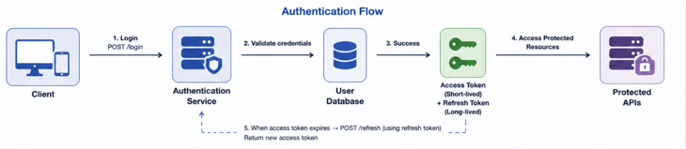
The flow of authentication includes a series of actions that occur between the client application and the Authentication Service. The credentials of users are entered through the login endpoint, after which the Authentication Service checks the email and password that have been provided. If the credentials are valid, both access token and refresh token will be issued. The access token is sent to the client application and later added to the Authorization header of requests. Once the access token is expired, the new one is acquired by accessing the refresh endpoint with the refresh token. After logging out, the refresh token becomes invalid, preventing any more authentication from being performed for the closed session. This flow provides efficient and secure authentication while preserving compatibility with the distributed system that is used by KriGo platform.
Figure 1 - Authentication API Flow

Customer APIs
The Customer APIs are the APIs containing the services which customers need for managing their personal accounts and using the vehicle rental service provided by the KriGo platform. The customer APIs include the set of functionalities that registered users have when authenticating in the system and accessing their accounts. They are the main means of personalizing customers' accounts and storing their personal data. The Customer APIs are built using the RESTful architectural style, with customer-related resources being exposed via standard endpoints and accessed with proper HTTP methods. Customer endpoints are secured by the use of JSON Web Tokens (JWT) and ensure that customers can only access and update their own resources. Additionally, there is a role-based authorization system which limits access to customer APIs to authenticated users. The customer management module is responsible for account administration and not for business logic operations such as making a reservation or payment which are performed by separate services.

Customer API Endpoints
Table 4 - Customer API Endpoints
Endpoint | Methode | Description | Auth
/api/v1/customers/profile | GET | Retrieve the authenticated customer's profile information | Yes
/api/v1/customers/profile | PUT | Update customer profile information | Yes
/api/v1/customers/avatar | POST | Upload or update the customer's profile picture | Yes
/api/v1/customers/password | PUT | Change the customer's password | Yes
/api/v1/customers/preferences | GET | Retrieve customer preferences | Yes
/api/v1/customers/preferences | PUT | Update customer preferences | Yes
/api/v1/customers/account | DELETE | Deactivate or delete the customer account | Yes

API Design Considerations
Customer APIs have been architected using the below rules:
- Customer Ownership: The customer is only allowed to change their personal details.
- RESTful Resources: Customer details have been created as RESTful resources using relevant URIs.
- JWT Auth: All APIs require an access token.
- Role-Based Access: Customer APIs can be accessed by the Customer role only.
- Data Validation: Data validation has been used before storing personal details.
- Privacy Protection: No password or any sensitive information will be revealed in the response.

Customer Profile Management Workflow
The process of profile management allows authenticated users to keep the data about their accounts safe.
- First, the customer is authenticated through the Authentication API, receiving an access token.
- The client application makes a request for fetching the profile data of the user.
- The Customer Service checks the access token and identifies the authenticated user.
- The data of the profile requested by the client is fetched from the database.
- If there are any changes to be made in the profile, the data entered is validated by the Customer Service.
- The profile data is changed, and the process is completed successfully.
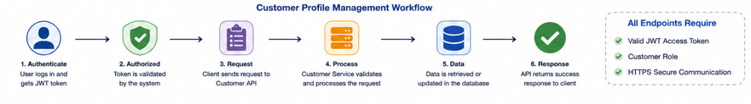
The Customer APIs offer secure and standardized methods for controlling the customers’ accounts in the KriGo system. With the use of RESTful techniques, JWT authentication and role-based authorization, the Customer APIs allow customers to keep their information intact in a way that preserves both security and privacy of the information. Also, the modular nature of the Customer service helps to separate this domain from others such as reservations, payments and fleet management.
Figure 2 - Customer API Flow

Vehicle & Search APIs
Vehicle & Search APIs represent the basic business logic of KriGo, which is responsible for searching for the available vehicles to get the required information about them. These APIs represent the interaction layer between client applications and the Fleet Management Service and allows getting the vehicle list filtered and sorted according to different criteria and getting up-to-date data about their availability, pricing, characteristics, and rental agencies.
The structure of Vehicle & Search APIs corresponds to REST architectural style, where vehicles are represented as resources and the search for them is performed via query parameters. In contrast to customer management services, these services can be called not only by authenticated but also by unauthenticated users to find the vehicles before registration. However, some features, such as recommendations or saved searches, are available only for the authenticated ones.
To increase performance, these APIs include advanced filters, sorting, and paging options to effectively get large datasets with low network load.

Vehicle & Search API Endpoints
Table 5 - Vehicle & Search API Endpoints
Endpoint | Method | Description | Auth
/api/v1/vehicles | GET | Retrieve all available vehicles | No
/api/v1/vehicles/{vehicleId} | GET | Retrieve detailed information about a specific vehicle | No
/api/v1/vehicles/search | GET | Search vehicles using keywords and search criteria | No
/api/v1/vehicles/filter | GET | Filter vehicles by category, price, transmission, fuel type, and availability | No
/api/v1/vehicles/compare | GET | Compare multiple vehicles | No
/api/v1/vehicles/nearby | GET | Retrieve vehicles available near a specified location | No
/api/v1/vehicles/categories | GET | Retrieve all available vehicle categories | No
/api/v1/vehicles/brands | GET | Retrieve supported vehicle brands | No
/api/v1/vehicles/{vehicleId}/availability | GET | Check vehicle availability for a selected rental period | No
/api/v1/vehicles/{vehicleId}/images | GET | Retrieve vehicle image gallery | No

API Design Considerations
The Vehicle & Search APIs follow the design principles below:
- RESTful Resource Design: Vehicles are modeled as REST resources which are uniquely identifiable through their URIs.
- Openness: Discovery of vehicles is available without the need for authentication to enable users' exploration.
- Efficient Searching: Search allows for keyword search together with filters.
- Pagination: Result sets are paginated for efficiency.
- Sorting Capabilities: Results may be sorted on price, popularity, rating, and latest posts.
- Availability in Real-Time: Availability of vehicles indicates real-time reservation status.
- JSON Response Structure: JSON responses are consistent across all endpoints.

Vehicle Search Workflow
Steps of searching for vehicles include the following:
- The client app makes a search request, including search filters (location, dates of the rental, type of vehicle, price range, type of transmission, or fuel type).
- The Fleet Management Service checks the validity of the search parameters.
- The service searches for vehicles in the vehicle database, excluding unavailable vehicles depending on the requested dates of the rental period.
- Search results are filtered by the specified criteria and sorted.
- The search result is sent to the client app along with basic information about the vehicles.
- When a user selects a particular vehicle, the client app asks for details about the selected vehicle via vehicle details endpoint.
This procedure allows customers to find appropriate rental vehicles.
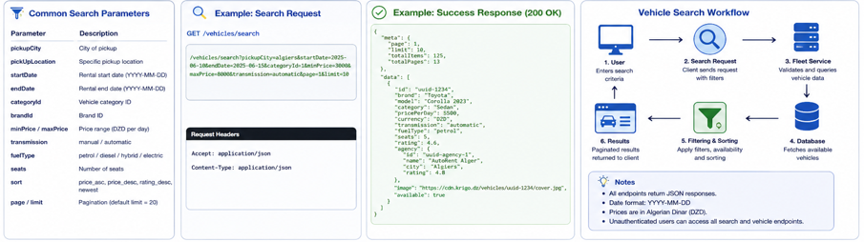
Figure 3 - Vehicle & Search Workflow

Reservation APIs
The Reservation APIs serve as the main business layer of the KriGo system, providing customers with functionality to book vehicles and letting agencies perform actions throughout the whole process of making reservations. They allow for the right coordination of interaction among customers, vehicles, agencies, and the payment system, allowing for correct booking while avoiding overlaps and multiple booking.
The Reservation APIs are developed under the principles of RESTful architecture, where reservations are considered resources, which go through states during their life cycle. They include data about a certain reservation, its customer, vehicle, and an agency, as well as such information as rental period, picking-up location, price and reservation state.
As the operations related to reservations involve sensitive customer data and money operations, all endpoints are protected through the use of JSON Web Tokens (JWT). Also, authorization is ensured by Role-Based Access Control (RBAC), which allows customers to interact with their reservations, while staff and administrators of agencies are provided with required permissions.
Reservation Service works with other backend services, such as Fleet Management Service for verifying the availability of vehicles, Payment Service for processing transactions, and Notification Service for notifications.

Reservation API Endpoints
Table 6 - Reservation API Endpoints
Endpoint | Method | Description | Auth
/api/v1/reservations | POST | Create a new vehicle reservation | Yes
/api/v1/reservations | GET | Retrieve reservations of the authenticated customer | Yes
/api/v1/reservations/{reservationId} | GET | Retrieve reservation details | Yes
/api/v1/reservations/{reservationId} | PUT | Update reservation information | Yes
/api/v1/reservations/{reservationId} | DELETE | Cancel an existing reservation | Yes
/api/v1/reservations/{reservationId}/status | PATCH | Update reservation status (Agency/Admin) | Yes
/api/v1/reservations/history | GET | Retrieve reservation history | Yes
/api/v1/reservations/{reservationId}/invoice | GET | Download reservation invoice | Yes

Design Considerations for API
The Reservations API follows these design considerations:
- RESTful Resource Model: Reservations are modeled as resources with unique identifier.
- JSON Web Token (JWT) Authentication: Access tokens are mandatory for all reservation endpoints.
- Role-Based Authorization: Customers can view only their reservations; agencies and admins view their reservations.
- Check Availability: Availability of vehicles will be checked before creating or updating the reservation to avoid booking conflicts.
- Reservation States: Reservations go through states like Pending, Confirmed, Active, Completed, and Cancelled.
- Transactions: Transactions are used to create reservations with payment transactions.
- Notifications: Notifications are sent out whenever there is any event for the reservation.

Workflow of Reservations
The procedure of reservation implies the following chain of actions:
- The authorized customer chooses a vehicle and indicates the dates of pickup and return.
- The client-side application sends the request for reservation to the Reservation Service.
- The Reservation Service identifies the customer and checks the availability of the chosen vehicle with the help of the Fleet Management Service.
- In case the vehicle is available, the reservation is made with the initial status of Pending.
- The Payment Service performs the payments and/or the reservation deposit based on the policy of the platform.
- After the successful verification of payment, the reservation status changes to Confirmed.
- The Notification Service delivers the notifications about the confirmed reservation to both customer and rental agency.
- The reservation moves through its lifecycle during the rental period till the status of Completed or Cancelled is reached.
The above mentioned workflow makes sure of the consistency of processing and synchronization of vehicle availability, payment, and customer notifications.

Agency Management API Specification
The Agency Management APIs represent the set of interfaces for agencies managing their operations inside the KriGo system. In contrast to the Customer APIs, whose aim is to discover vehicles and make reservations, the Agency Management APIs are solely aimed at administering agency resources, such as fleet management, reservation management, employee management, and performance tracking. This set of interfaces allows agencies to conduct their operations effectively and, at the same time, keep customer information current and correct.

Fleet Management APIs
The Fleet Management APIs offer all the necessary features for managing the vehicles available through the KriGo platform. The API allows registering new vehicles, managing vehicle details, handling pricing and availability, uploading vehicle pictures, and deleting unavailable for renting vehicles. Being an important part of the platform, the Fleet Management Service makes sure that vehicle information is always correct, relevant, and coordinated with the reservation operations.
As part of the RESTful architecture of KriGo, each vehicle is considered as a resource identified with its own unique identifier. All fleet management operations require authentication via JSON Web Tokens (JWT), whereas authorization occurs via the Role-Based Access Control (RBAC) system. Thus, only the employees of the agency can handle the vehicles of their agency, while admins have more permissions for moderation.
In order to make sure that there are no conflicts in the system, the Fleet Management Service works together with the Reservation Service in order not to alter the reservation operations. Additionally, it works with the Notification and Analytics services in order to keep the inventory up-to-date and update the reports respectively.

Fleet Management API Endpoints
Table 7 - Fleet Management API Endpoints
Endpoint | Method | Description | Auth
/api/v1/fleet/vehicles | POST | Register a new vehicle | Yes
/api/v1/fleet/vehicles | GET | Retrieve all vehicles belonging to the authenticated agency | Yes
/api/v1/fleet/vehicles/{vehicleId} | GET | Retrieve detailed vehicle information | Yes
/api/v1/fleet/vehicles/{vehicleId} | PUT | Update vehicle information | Yes
/api/v1/fleet/vehicles/{vehicleId} | DELETE | Remove a vehicle from the fleet | Yes
/api/v1/fleet/vehicles/{vehicleId}/availability | PATCH | Update vehicle availability status | Yes
/api/v1/fleet/vehicles/{vehicleId}/price | PATCH | Update rental pricing | Yes
/api/v1/fleet/vehicles/{vehicleId}/images | POST | Upload vehicle images | Yes
/api/v1/fleet/vehicles/{vehicleId}/images/{imageId} | DELETE | Delete a vehicle image | Yes
/api/v1/fleet/statistics | GET | Retrieve fleet statistics and inventory summary | Yes

API Design Considerations
The Fleet Management APIs are built taking into account the following factors:
- Ownership Factor: An agency may control only the vehicles belonging to its own organization.
- REST Resources Modeling: The vehicles are presented as REST resources and have unique IDs.
- Authorization by JWT: All fleet operations require access tokens.
- Authorization by Roles: Fleet management is performed only by agency managers, agency workers with certain permissions, and administrators.
- Control of Vehicles' Availability: Updates about availability of vehicles are synchronized with Reservation Service in order to avoid booking the same vehicle twice.
- Support of Multiple Images: Several images may be associated with each vehicle in order to make it more visible to customers.
- Protection of Vehicle Inventory: It is impossible to delete from the fleet vehicles involved in active reservations until all of them will be closed or cancelled.
- Data Validity: All the vehicle specifications, price and policy information are checked before storage.

Fleet Management Workflow
The process of fleet management includes the following sequence of operations:
- An authenticated agency worker launches the Fleet Management module.
- The worker creates or updates a vehicle record.
- The Fleet Management service validates the vehicle record information.
- The images of the vehicle are uploaded.
- The vehicle record is saved in the database and becomes visible to customers if its availability state is 'Available'.
- In case of any change in price or availability, the Reservation Service is informed about it.
- The Analytics information is updated.
This process guarantees the accuracy of the information about vehicles and keeps consistency in reservation, searching and analytics services.

Branch Management APIs
The Branch Management APIs allow agencies to manage their branches within the KriGo platform. Since the agency might be operating from different geographical locations, the APIs offer standard services for creating, modifying, fetching, and managing information about their branches. Every branch is a physical rental office where customers can rent and return the vehicle; hence, efficient branch management will help distribute the fleets efficiently.
The Branch Management APIs follow the RESTful architectural style, where every branch will be considered a resource with a unique identifier. All branch management requests will need authentication through JSON Web Tokens (JWT), but authorization is carried out using Role-Based Access Control (RBAC). This means that only those agency managers and employees who have been granted permission to do so will be allowed to manage branches within their agencies, but platform administrators will have full access to everything.
There is an association between the Branch Management Service and other services like Fleet Management Service and Reservation Service since vehicles are assigned to particular branches, and the reservations depend on branch information to work.

Branch Management API Endpoints
Table 8 - Branch Management API Endpoints
Endpoint | Method | Description | Auth
/api/v1/branches | POST | Create a new branch | Yes
/api/v1/branches | GET | Retrieve all branches of the authenticated agency | Yes
/api/v1/branches/{branchId} | GET | Retrieve branch details | Yes
/api/v1/branches/{branchId} | PUT | Update branch information | Yes
/api/v1/branches/{branchId} | DELETE | Remove a branch | Yes
/api/v1/branches/{branchId}/status | PATCH | Activate or deactivate a branch | Yes
/api/v1/branches/{branchId}/vehicles | GET | Retrieve vehicles assigned to a branch | Yes
/api/v1/branches/{branchId}/employees | GET | Retrieve employees assigned to a branch | Yes
/api/v1/branches/{branchId}/operating-hours | PATCH | Update branch operating hours | Yes

API Design Considerations
Branch Management APIs are developed on the following basis:
- Agency Ownership: An agency can manage only its own branches.
- REST Resource Modeling: Branches will be modeled as REST resources and will have unique IDs.
- JWT Authentication: Access token is needed to use all the endpoints of the branch management.
- Role-based Authorization: Agency manager, branch manager, and administrator roles are allowed to perform branch management operations.
- Location Integrity: Each branch will keep unique location information, which includes address and geographic coordinates.
- Consistency: Updates of the information about branches will be kept consistent with fleet and reservation services.
- Soft Deletion: The branches linked with the operational vehicles or reservations cannot be deleted until these relationships are sorted out.
- Data Validation: Address, contact information, operating hours and other branch data will be validated before persisting.

Branch Management Workflow
Branch management process includes the following operations:
- An agency manager logs into the Branch Management module using the authentication.
- The manager creates a new branch or updates the information about the existing branch.
- The information is validated by the Branch Management Service, and the validation includes address, contact information and operating hours of the branch.
- The information is persisted in the database.
- Vehicles and employees can be assigned to the branch.
- Fleet Management and Reservation Services synchronize the information about the branch in order to keep pickup and return location data accurate.
- The updated information will be available for customers searching for rental vehicles through the Vehicle Search APIs.
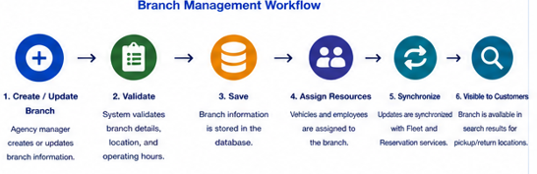
Figure 4 - Branch Management Workflow

Employee Management APIs
Employee Management APIs allow rental agencies to control employee accounts and to limit access to resources required for agency's operation in KriGo platform. This API allows agencies' administrators to create, modify and deactivate employee accounts, set roles and permissions, and control status of employees. Thus, the platform provides means for controlling operations related to personnel management, which allows performing business processes with increased efficiency and security.
Employee Management APIs use REST architecture style, according to which employees are treated as resources identified by their unique identifiers. Authentication in all of the operations performed on employee management resource is done using JSON Web Tokens (JWT) and authorization is controlled using RBAC. Therefore, only administrators from respective agencies and managers authorized to perform this operation are able to manage employee accounts and their permissions.
Employee Management Service works in close interaction with Authentication Service and Agency Management Service. Employees' accounts belong to a certain agency and are authenticated using centralized authentication process. Assignment of roles and permissions allows limiting the access of employees to agency's resources.

Employee Management API Endpoints
Table 9 - Employee Management API Endpoints
Endpoint | Method | Description | Auth
/api/v1/employees | POST | Create a new employee account | Yes
/api/v1/employees | GET | Retrieve all employees of the authenticated agency | Yes
/api/v1/employees/{employeeId} | GET | Retrieve employee details | Yes
/api/v1/employees/{employeeId} | PUT | Update employee information | Yes
/api/v1/employees/{employeeId} | DELETE | Remove an employee account | Yes
/api/v1/employees/{employeeId}/status | PATCH | Activate or deactivate an employee account | Yes
/api/v1/employees/{employeeId}/role | PATCH | Update employee role and permissions | Yes
/api/v1/employees/{employeeId}/reset-password | POST | Reset employee password | Yes
/api/v1/employees/roles | GET | Retrieve available employee roles | Yes

API Design Considerations
The Employee Management APIs have been designed on the basis of the following design considerations:
- Ownership of Agencies: Agencies may manage only those employees which belong to their organizations.
- REST Resources Representation: Employee resources will be modeled in terms of REST resources which will have unique resource identifiers.
- JWT Authentication: All operations related to the management of employee resources require valid access token.
- Authorization Based on Role: Management of employee accounts may be done only by agency administrators and managers authorized for that.
- Permission Management: Permission to access operational resources such as fleet, reservation and branches, etc. will depend upon roles of employee.
- Account Management: Password management and account activation is taken care by the Authentication Service.
- Data Validation: Information about the employee and his/her assigned roles are validated before persisting the data.
- Audit: All changes made to employee accounts are being logged.

Employee Management Workflow
- The employee management process consists of the following operations:
- Authentication service logs in an agency administrator through Employee Management module.
- The administrator creates new employee account or updates information of existing employee.
- The Employee Management Service validates the data submitted about the employee.
- Organizational role and permissions are assigned to the employee.
- Authentication Service creates or updates authentication credentials of the employee.
- The employee account is activated and assigned agency and branch information.
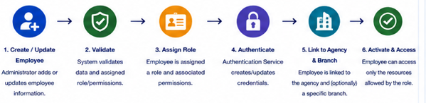
- Employee can access only those resources whose permission he/she has got because of their role.
Figure 5 - Employees Management Workflow

Reporting APIs
The Reporting APIs allow rental agencies to analyze the performance of the business through full operational reports and statistics. The Reporting APIs give the managers of rental agencies access to the real-time and historic information about reservations, fleet usage, revenues, user activities, and branch performance. The conversion of the operational data into valuable business insights is provided by the Reporting APIs.
The Reporting APIs are developed based on the RESTful architecture style. In such a way, reports are created dynamically using validated request parameters and are not kept as persistent resources. Every operation with the Reporting API requires the authorization with JWT tokens, and the RBAC is used for the authorization. Thus, the reports available for the managers of the rental agencies are limited to the respective agencies, and the platform-wide reports are available to the platform administrators.
The Reporting Service gathers data from various backend services, namely from the Reservation Service, Fleet Management Service, Payment Service, and Branch Management Service. In such a way, the generated reports contain consistent information about the actual status of the platform.

Reporting API Endpoints
Table 10 - Reporting API Endpoints
Endpoint | Method | Description | Auth
/api/v1/reports/dashboard | GET | Retrieve agency dashboard statistics | Yes
/api/v1/reports/revenue | GET | Generate revenue reports | Yes
/api/v1/reports/reservations | GET | Generate reservation statistics | Yes
/api/v1/reports/fleet-utilization | GET | Retrieve fleet utilization reports | Yes
/api/v1/reports/vehicles | GET | Generate vehicle performance reports | Yes
/api/v1/reports/customers | GET | Generate customer activity reports | Yes
/api/v1/reports/branches | GET | Retrieve branch performance reports | Yes
/api/v1/reports/export | POST | Export reports in PDF or Excel format | Yes
/api/v1/reports/summary | GET | Retrieve overall business performance summary | Yes

API Design Considerations
The Reporting APIs have been designed in compliance with a number of principled design guidelines:
- RESTful Service Design: The generation of reports takes place via the utilization of standard REST endpoints, using HTTP GET and POST requests.
- JWT Authentication: The reporting endpoints must always be accessed via a valid access token.
- Role-Based Authorization: The access to reports depends on agency ownership and role.
- Data Aggregation across Multiple Services: Reports aggregate data from the services related to reservations, fleet, payments, and branches.
- Real-time Analytics: The dashboard statistics include the latest operational data in the system.
- Filtering Options: Reports allow for filtering by date range, branch, vehicle category, reservations status, and other business parameters.
- Export Options: Reports may be exported in popular formats, such as PDF and Microsoft Excel.
- Performance Optimization: Popular reports may be cached in order to reduce the burden on the database and improve performance.

Reporting Workflow
The reporting process consists of the following sequence of steps:
- The authenticated manager accesses the reporting dashboard.
- The manager chooses the type of a report and sets any optional filters for it (e.g., date range, branch, or vehicle category).
- The Reporting Service authenticates the request and collects the required data from relevant backend services.
- The gathered data are aggregated, processed and converted into statistical and performance indicators.
- The report is delivered back to the client application in order to display it.
- If the export is requested, the report will be saved as a PDF or Excel file.
Such workflow allows for efficient monitoring of business performance through accurate and updated reporting data.
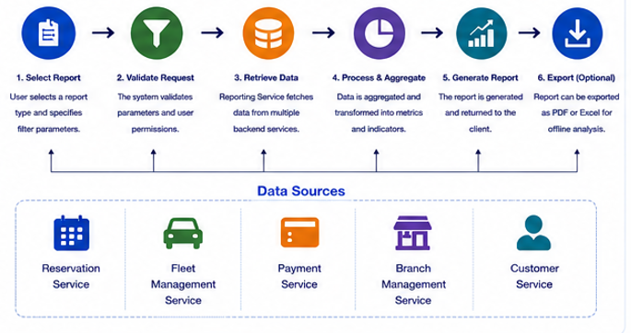
Figure 6 - Reporting Workflow

Administration API Specification
Administration APIs are provided with the capabilities needed to govern and supervise the general operation of the KriGo platform. In comparison with Customer APIs and Agency Management APIs, which are mostly oriented towards operations performed by end-users and agencies respectively, the Administration APIs have been created especially for the administrators of the platform who are responsible for maintaining platform integrity, enforcing policies of the platform and monitoring the performance of operations on it.
The Administration APIs operate according to RESTful architecture principles and represent the set of services which can be used to manage platform resources including user accounts, rental agencies, vehicles, reservations, system reports, and administrative configurations. The use of these APIs allows the administrators to perform such important governance tasks as approving agency registration requests, moderating platform content, monitoring user activities and obtaining platform reports and analytics.
Because of the special nature of administrative operations, all the Administration APIs are protected with Role-Based Access Control and require JSON Web Tokens for authentication. The access to these APIs can only be gained by users who are assigned with the Administrator role thus preventing any access to the platform resources and configurations which could compromise platform security. Moreover, there are special audit logs available for the documentation of administrative actions.
The Administration APIs work with such backend services as Authentication Service, Agency Management Service, Fleet Management Service, Reservation Service, Reporting Service and Notification Service. Using the Administration APIs to coordinate actions of these backend services helps to monitor the platform, control its resources and perform other administrative tasks while maintaining the modular design approach to the KriGo system.

User Management APIs
The User Management APIs provide the administrators with the features necessary to manage user accounts within the KriGo platform. These APIs allow the administrators of the platform to view user details, check the status of the accounts, edit the user details, activate or deactivate the user accounts, and perform other administrative functions that are integral to platform security.
The User Management APIs are implemented following the RESTful architecture, where the user is a resource that has its identifier. Every action performed on the user account requires authentication through JWT and authorization using RBAC. These endpoints are available only to users having the Administrator role; no other user can have permissions for executing account management functions.
The User Management Service works together with the Authentication Service to keep the user account details and access management, and it also interacts with other platform services to track all user activity, reservations, and agencies where they work when relevant. Administrative actions performed through the User Management APIs are logged in the audit log.

User Management API Endpoints
Table 11 - User Management API Endpoints
Endpoint | Method | Description | Auth
/api/v1/admin/users | GET | Retrieve all registered users | Yes
/api/v1/admin/users/{userId} | GET | Retrieve detailed user information | Yes
/api/v1/admin/users/{userId} | PUT | Update user information | Yes
/api/v1/admin/users/{userId} | DELETE | Permanently remove a user account | Yes
/api/v1/admin/users/{userId}/status | PATCH | Activate or suspend a user account | Yes
/api/v1/admin/users/{userId}/role | PATCH | Update user role and permissions | Yes
/api/v1/admin/users/search | GET | Search users using various criteria | Yes
/api/v1/admin/users/statistics | GET | Retrieve user statistics and account summary | Yes
/api/v1/admin/users/{userId}/reset-password | POST | Reset a user's password | Yes

API Design Considerations
User Management APIs are implemented with regard to the following considerations:
- Access Control: All the endpoints are available only to authenticated administrators.
- REST Resources Representation: User accounts are REST resources having unique identifiers.
- JWT Access Token: Every API call should contain valid JWT access token.
- Authorization Based on Roles: The set of the possible operations with user accounts depends on administrative permissions.
- Account Validation: Critical API calls that change the account state or roles require additional validation in order to avoid accidental or unauthorized changes.
- Audit Tracking: Every action taken by an administrator is logged.
- Privacy: Sensitive information like passwords and authentication credentials is not revealed in API responses.
- Efficiency of Administration: User retrieval endpoints provide pagination, filtering and sorting capabilities for large user datasets.

User Management Workflow
The process of user management includes the following steps:
- Authenticated administrator enters User Management module.
- Administrator receives the list of users or finds the user account of interest.
- User Management service verifies the authorization of the administrator.
- Administrator executes the required operation on the account.
- User Management service checks and makes the necessary changes to the user account.
- Authentication service updates credentials or access rights if needed.
- Action is logged in audit, and updated data is sent to administrator.
The described workflow allows user accounts management while ensuring consistency between account information, authentication credentials and authorization policies.
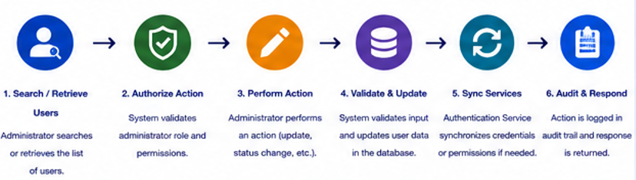
Figure 7 - User Management Workflow

Verification APIs
Verification APIs give administrators the ability to verify and manage agencies registered on the KriGo platform. This API allows administrators to check whether the registered agencies comply with the set criteria so as to allow them to be used as rental agencies for the provision of services on the KriGo platform. Administrators will be able to perform a verification process of the agencies' registration data, documents, and other operational information.
The verification APIs are developed following the RESTful architectural styles where each request to perform a verification process is regarded as a resource identified using unique IDs. Authentication in these APIs is done using the JSON Web Tokens (JWT) while authorization is implemented using the Role Based Access Control method (RBAC). These APIs can be accessed only by administrators who are allowed to use them.
Verification service works in conjunction with the agency management service, authentication service, and notification service. After approving or rejecting an agency, its account is updated with its new status and notification messages are sent to the agency to let it know about the result of verification process. All the verifications performed are logged in the audit log.

Verification API Endpoints
Table 12 - Verification API Endpoints
Endpoint | Method | Description | Auth
/api/v1/admin/verifications | GET | Retrieve all agency verification requests | Yes
/api/v1/admin/verifications/{verificationId} | GET | Retrieve verification request details | Yes
/api/v1/admin/verifications/{verificationId}/approve | PATCH | Approve an agency verification request | Yes
/api/v1/admin/verifications/{verificationId}/reject | PATCH | Reject an agency verification request | Yes
/api/v1/admin/verifications/{verificationId}/request-info | POST | Request additional verification documents | Yes
/api/v1/admin/verifications/pending | GET | Retrieve all pending verification requests | Yes
/api/v1/admin/verifications/history | GET | Retrieve verification history | Yes
/api/v1/admin/verifications/statistics | GET | Retrieve verification statistics | Yes

API Design Considerations
The Verification APIs have been built adhering to the following principles:
- Administrator Access Only: The actions involved in the verification procedure may be done by authenticated administrators only.
- RESTful Resources: Verification requests should be modeled using REST resources, each having unique identifiers.
- JWT Authentication: All requests must include a valid access token in JSON Web Token format.
- Authorization: Only those users who belong to the Administrator role will be able to approve or reject the verification requests.
- Validation: The uploaded verification documents are subject to validation before the approval is done.
- Integrity of workflow: There are certain states of verification requests (Pending, Under Review, Approved, Rejected, Additional Information Required).
- Logging: Each verification action should be logged for audit purposes.
- Notifications: Agencies will be notified automatically in case of any changes in the status of their verification request.

Verification Workflow
The verification process involves the following sequence of actions:
- The agency uploads its registration information and all required verification documents.
- The Verification Service records the request and sets it to the Pending state initially.
- Authenticated administrator reviews the provided information and verification documents.
- In case if needed, the administrator asks for the additional information from the agency.
- After reviewing the verification request, the administrator either approves or rejects it.
- Agency Management Service updates the status of the agency account based on the result of the verification process.
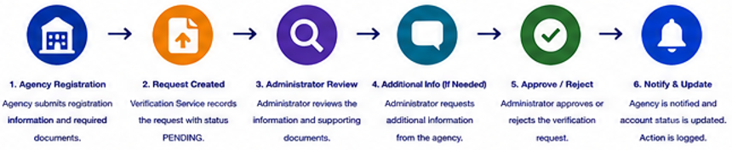
- The Notification Service notifies the agency about the verification result, and the administrative action is logged.
Figure 8 - Verification Workflow

Moderation APIs
The Moderation APIs allow administrators to perform operations for monitoring, reviewing, and moderating the user-generated content on KriGo platform. With the help of moderation APIs, the platform provides administrators the functionality to manage customer reviews, reports about inappropriate content, users' complaints, and violations of the policies. The publication of content can be controlled by providing appropriate moderation services, which guarantee that all published content follows the community guidelines and standards and protects users from getting any misleading information.
The Moderation APIs follow the architectural style of REST, where moderation requests and reported content are represented as resources that are uniquely identifiable. All moderation APIs require users to authenticate themselves using the JSON Web Token (JWT). Authorization is provided through Role-Based Access Control (RBAC), where access to these endpoints is limited to users having the Administrator role.
The Moderation Service interacts with the Review Service, Customer Service, Agency Management Service, and Notification Service. Upon approving, removing, or flagging of any content by the administrators, the record of such action gets automatically updated and notifications get delivered to the affected users.

Moderation API Endpoints
Table 13 - Moderation API Endpoints
Endpoint | Method | Description | Auth
/api/v1/admin/moderation/reports | GET | Retrieve all reported content | Yes
/api/v1/admin/moderation/reports/{reportId} | GET | Retrieve report details | Yes
/api/v1/admin/moderation/reports/{reportId}/approve | PATCH | Approve reported content | Yes
/api/v1/admin/moderation/reports/{reportId}/reject | PATCH | Reject a report | Yes
/api/v1/admin/moderation/reviews | GET | Retrieve customer reviews for moderation | Yes
/api/v1/admin/moderation/reviews/{reviewId} | DELETE | Remove an inappropriate review | Yes
/api/v1/admin/moderation/users/{userId}/warnings | POST | Issue a warning to a user | Yes
/api/v1/admin/moderation/users/{userId}/suspend | PATCH | Suspend a user for policy violations | Yes
/api/v1/admin/moderation/statistics | GET | Retrieve moderation statistics | Yes

API Design Considerations
Moderation APIs adhere to the following principles:
- Access Restricted to Administrators: Moderation API requests should be made only by authorized administrators.
- RESTful Resource Modeling: Reports, reviews, and moderation API operations should use REST resources.
- JWT Authentication: Each API request should be accompanied by a valid JWT access token.
- Authorization Based on Roles: Only administrators have the authority to moderate.
- Preservation of Content Integrity: Any moderation actions are aimed at preserving consistency of platform data and implementing community policies.
- Auditing: All moderation actions are logged for auditing purposes.
- User Notification: Moderation actions that affect the user's content or account should trigger notifications to the affected user.
- Scalable Filtering Capabilities: Moderation APIs provide pagination, filtering and sorting capabilities for efficient processing of many reports.

Moderation Workflow
The Moderation Workflow includes the following set of actions:
- Customer or an agency reports an instance of inappropriate content or policy violation.
- The Moderation Service saves the report in a Pending state.
- An authenticated administrator reviews the content and supporting documents.
- The administrator makes a decision to approve the report, reject it, delete the content, warn or suspend a user.
- The corresponding content or user account is updated based on the decision.
- Notification Service notifies relevant users about the decision.
- The action is recorded in the audit log.
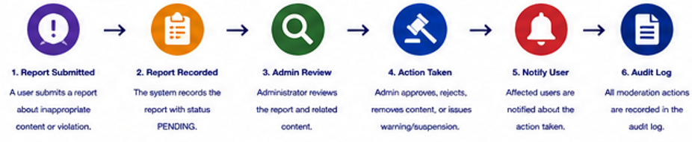
Figure 9 - Moderation Workflow

Dispute Management APIs
The Dispute Management APIs offer the capabilities necessary for administrators to be able to manage and resolve disputes that have emerged between customers and rental agencies on the KriGo platform. In particular, the dispute management API allows administrators to examine disputes, investigate evidence, interact with the involved parties, and make decision in relation to dispute resolution, in accordance with the guidelines set out in the platform policies.
The Dispute Management API follows RESTful architecture, with each dispute being considered a resource, which is uniquely identified using a unique identifier. Each operation concerning dispute management should involve authentication via JSON Web Token (JWT) and authorization using the Role-Based Access Control approach. In addition, access to this API endpoint is allowed to only users who have the Administrator role.
Dispute Management API interacts with Reservation Service, Payment Service, Customer Service, Agency Management Service, and Notification Service. It allows administrators to examine details of reservations and payments, receive customer complaints, and investigate agency records. Following the resolution of a dispute, the system automatically updates its status and stores administrative decision in an audit log. In addition, it notifies parties involved about the decision.

Dispute Management API Endpoints
Table 14 - Dispute Management API Endpoints
Endpoint | Method | Description | Auth
/api/v1/admin/disputes | GET | Retrieve all disputes | Yes
/api/v1/admin/disputes/{disputeId} | GET | Retrieve dispute details | Yes
/api/v1/admin/disputes/{disputeId}/assign | PATCH | Assign a dispute to an administrator | Yes
/api/v1/admin/disputes/{disputeId}/resolve | PATCH | Resolve a dispute | Yes
/api/v1/admin/disputes/{disputeId}/close | PATCH | Close a resolved dispute | Yes
/api/v1/admin/disputes/{disputeId}/comment | POST | Add an administrative comment | Yes
/api/v1/admin/disputes/history | GET | Retrieve dispute history | Yes
/api/v1/admin/disputes/statistics | GET | Retrieve dispute statistics | Yes

API Design Considerations
The Dispute Management APIs have been implemented in accordance with the following design guidelines:
- Access Limited to Administrators: Disputes can only be managed by authenticated administrators.
- REST Resource Model: Disputes are described as RESTful resources that use unique identifiers.
- JWT Authentication: Each request should include a valid JWT access token.
- Authorization: Only administrators have the authorization to investigate and solve the disputes.
- Evidence: Evidence in the form of documents, images, and other records can be attached during the dispute investigation.
- State Life Cycle: Disputes change through predefined states like Open, Under Review, Resolved, and Closed.
- Logging: Actions of the administrators while resolving disputes are logged in audit logs.
- Notifications: The customers and the agencies receive notifications when the dispute status changes.

Dispute Management Workflow
Dispute resolution process involves the following steps:
- Dispute about the reservation, payment, or other service issue is submitted by either the customer or the rental agency.
- Dispute is entered into the Dispute Management Service with the status set to Open.
- An authenticated administrator reviews the submitted dispute and attached evidence.
- Additional data might be requested if necessary.
- Dispute is investigated and the solution is decided.
- The status of the dispute is set to Resolved or Closed accordingly.
- Notification Service sends the notification about the resolution to the customer and the agency.
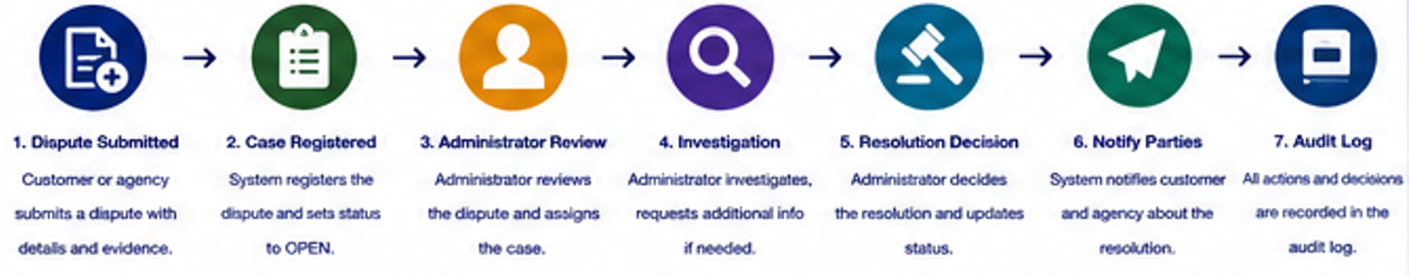
Figure 10 - Dispute Management Workflow

Integration API Specification
The Integration APIs act as a tool for communicating between the KriGo platform and external systems. Unlike the Customer APIs, the Agency Management APIs and the Administration APIs, the purpose of the Integration APIs is to perform secure data exchange with third-party providers to improve the functionality of the platform and the user experience. The provided integrations will allow the platform to use specialized services without affecting its modular structure.
Integration APIs are designed according to the RESTful architecture principles with the implementation of standardized protocols to ensure interconnectivity, scalability and maintainability. Third-party services connect to the KriGo platform using the available API endpoints with the data exchange using JSON over HTTPS. Depending on the requirements of each particular service, authentication via API key, OAuth 2.0 protocol or JSON Web Token (JWT) is used, while all the communications are secured with TLS.
From the architectural perspective, the Integration APIs represent the independent services designed to separate the external dependencies from the business logic. As a result, the level of the coupling between the internal components and third-party providers is minimized, thus making it possible to replace or extend the external services without affecting the whole platform. Besides that, the integration services include error handling, request retries, validation and logging for the reliable communication and monitoring.
In the KriGo platform, there are several important external services integrated through the use of Integration APIs such as payment, email, SMS, cloud, mapping and identity verification services when needed. This enables performing payment operations securely, sending customer notifications, searching for vehicles by location and other useful features.

Payment Integration APIs
The Payment Integration APIs contain all the functionalities necessary to process secure payments via the KriGo platform. They establish connections between the platform and third party payment gateways. With their help, clients can pay for the reservation, get a refund, and check the transaction status.
The Payment Integration APIs are implemented according to REST principles and payment processing workflow. Instead of processing payments on its own and handling payment information, KriGo platform uses certified third-party payment service providers, which allows simplifying payment processing, minimizing security risks and reducing the number of actions associated with this process.
The communication related to the payments is protected by means of HTTPS and TLS. The external payment providers can use either API keys, or OAuth 2.0 access tokens, or digital signatures for authentication. To ensure the safety of financial operations, the payments are validated and checked against modifications after that the payment requests are sent.
The Payment Integration Service interacts with Reservation Service, Customer Service, Notification Service, and Reporting Service. When a customer makes a reservation, the Reservation Service generates a payment request and sends it to the external payment gateway. After receiving a confirmation from the external payment gateway, the reservation status is changed, the customer receives a payment confirmation message, and the transaction is reported and logged. Similarly, the refund operations synchronize the status of the payments with the status of the reservation records.

Payment Integration API Endpoints
Table 15 - Payment Integration API Endpoints
Endpoint | Method | Description | Auth
/api/v1/integrations/payments/ | POST | Create a payment transaction | Yes
/api/v1/integrations/payments/{paymentId} | GET | Retrieve payment details | Yes
/api/v1/integrations/payments/{paymentId}/status | GET | Retrieve payment status | Yes
/api/v1/integrations/payments/{paymentId}/confirm | POST | Confirm a successful payment | Yes
/api/v1/integrations/payments/{paymentId}/cancel | POST | Cancel a payment transaction | Yes
/api/v1/integrations/payments/{paymentId}/refund | POST | Process a payment refund | Yes
/api/v1/integrations/payments/webhook | POST | Receive payment gateway webhook notifications | No (Verified by Digital Signature)
/api/v1/integrations/payments/history | GET | Retrieve payment transaction history | Yes

API Design Considerations
The Payment Integration APIs follow the design principles that include:
- Secure Communication: The payment requests are delivered via HTTPS using TLS encryption.
- Third-Party Payment Processing: Payment details are handled only by certified third-party payment gateways.
- RESTful API: Payments are done using the REST principle and JSON protocol.
- Authentication and Authorization: Either API keys, OAuth 2.0 or JWT tokens are used as per security requirements of the external provider.
- Webhook Validation: The received payments are verified via digital signatures.
- Transaction Integrity: Each payment transaction receives unique ID for future audits.
- Refunds: The refunding process is coordinated with reservations.
- Error Handling: Transactions are retried if failed or duplicated, and network errors are handled in case of failed communication.

Payment Processing Workflow
The payment process includes the following steps:
- The client confirms the car reservation and decides on using online payment methods.
- The Reservation Service creates the request and passes it to the Payment Integration Service.
- The Payment Integration Service contacts the external payment gateway securely.
- The client uses the provider's payment interface to complete the payment.
- The payment gateway either returns the results or notifies the platform via webhook.
- The Payment Integration Service verifies the results and changes the state of the reservation.
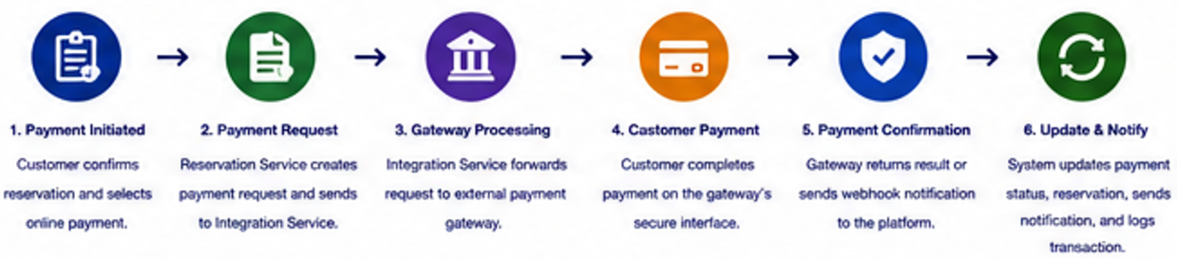
- The Notification Service informs the client about the payment, and the Reporting Service registers the completed transaction for the financial audit.
Figure 11 - Payment Processing Workflow

AI Service APIs
The AI Service APIs contain the features required for implementing artificial intelligence within the KriGo platform. Some of the features provided by AI services include personalized vehicle recommendations, semantic vehicle search, natural language processing, predictive analytics, and automated customer support. Using AI services, the platform will improve the user experience, increase efficiency and make data-driven decisions for its customers, rental agencies and administrators.
The AI Service APIs are built based on RESTful architecture principles and provide the communication interface between the platform and AI services used either externally or deployed within the platform itself. Communication between application services and AI engine takes place using JSON format over HTTPS protocol to ensure secure and reliable communication. As AI services operate independently from the business logic, they can be changed, upgraded or scaled up/down without interfering other parts of the platform.
Authentication for the AI service requests is done by using JSON Web Token (JWT). Authorization is done based on the role of the requesting user. Endpoints used by customers provide personalized recommendations and intelligent vehicle search while endpoints used by rental agencies and administrators are focused on analytics, forecasting and operational insights. To ensure security and privacy of personal information, only the required minimum business data is sent to the AI service and all the communication channels are secured by TLS.
AI Service works with several backend services which include Vehicle Search Service, Reservation Service, Customer Service, Reporting Service and Notification Service. Intelligent recommendations and predictions are made based on the analysis of the vehicle information, reservation history, customer preferences and operational statistics. The results generated by the AI service are sent back to the requesting service and shown to the users via web or mobile application.

AI Service API Endpoints
Table 16 - AI Service API Endpoints
Endpoint | Method | Description | Auth
/api/v1/integrations/ai/recommendations | POST | Generate personalized vehicle recommendations | Yes
/api/v1/integrations/ai/search | POST | Perform AI-powered semantic vehicle search | Yes
/api/v1/integrations/ai/chat | POST | Process customer chatbot requests | Yes
/api/v1/integrations/ai/demand-forecast | GET | Retrieve vehicle demand predictions | Yes
/api/v1/integrations/ai/pricing | GET | Generate intelligent pricing recommendations | Yes
/api/v1/integrations/ai/sentiment | POST | Analyze customer reviews and feedback | Yes
/api/v1/integrations/ai/insights | GET | Retrieve operational AI insights | Yes
/api/v1/integrations/ai/model-status | GET | Retrieve AI service availability and model status | Yes

API Design Considerations
AI Service APIs are specified based on the following principles:
  - RESTful API Design: AI Services are exposed using REST endpoints with JSON payload;
  - JWT Authentication: Requests require a valid JWT access token;
  - Role-based Authorization: AI capabilities are distributed based on permissions of customers, agencies, or administrator;
  - Secure Communication: Requests are sent over HTTPS using TLS protocol;
  - Privacy Protection: Only minimal amount of required information for AI service is shared to preserve privacy of users;
  - Model Independence: AI models are separated from platform architecture allowing independent deployment and update;
  - Scalable Processing: Processing of AI request is performed asynchronously in case of computation-heavy operations;
  - Standardized Error Handling: Failures of AI service are handled with standardized error responses.

AI Service Workflow
AI processing flow consists of the following steps:
- Authenticated user sends a request related to AI capabilities such as recommendations, intelligent search, or chatbot query;
- Requesting service verifies user's authentication and authorization;
- AI Integration Service gathers all needed contextual data from other platform services;
- Request is sent to the AI engine over HTTPS using TLS;
- AI model analyses input data and produces the requested prediction, recommendation or response;
- Output is returned back to AI Integration Service and undergoes validation process;
- Processed response is sent to client application and, if required, is logged to be used for monitoring and further improvement of the model.
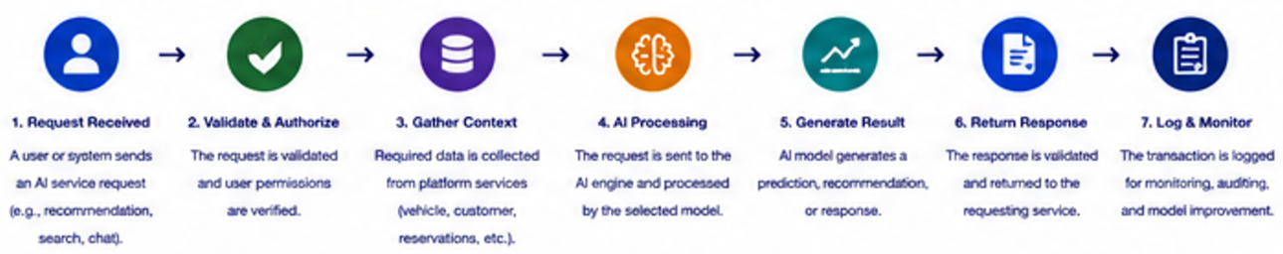
Figure 12 - AI Service Workflow

Maps Service APIs
The Maps Service APIs offer the required functionality needed to provide the capability to integrate mapping, geolocation and navigation features into the KriGo platform. Using the Maps Service APIs, the customers will be able to find nearby rental agencies, find vehicles based on their geographical location, calculate the distance between pick up and return locations as well as get the navigation information. Using mapping service makes it possible to improve the experience of searching for vehicles and increases operational efficiency of rental agencies.
The Maps Service APIs are developed using REST architecture principles and communication protocols providing secure and reliable interaction with third-party mapping services. Requests and responses are sent in JSON format over HTTPS. Using the integration layer allows the platform to work with different third-party mapping providers by abstracting the implementation of the services. The KriGo platform is able to replace or add new mapping providers without affecting the business services provided.
All the map requests should be authenticated with the help of JSON Web Token (JWT) for the authenticated user, but some location services might be available without authentication depending on the application requirements. All communications with the third-party mapping services are secured with the help of HTTPS using TLS protocol and API keys that are provided by the mapping provider are used for requests authorization. Minimum geographical data is transferred to the external services required for performing particular request.
The Maps Service works together with the following services: Vehicle Search Service, Branch Management Service, Reservation Service, and Customer Service. Branch coordination and vehicle availability are connected with maps data to show nearby rental places, calculate travel distance, validate addresses and allow the customer to use geographical data to find the vehicles. The navigation data can also be provided to the customers for pick-up and return locations.

Maps Service API Endpoints
Table 17 - Maps Service API Endpoints
Endpoint | Method | Description | Auth
/api/v1/integrations/maps/geocode | POST | Convert an address into geographic coordinates | Yes
/api/v1/integrations/maps/reverse-geocode | POST | Convert geographic coordinates into a readable address | Yes
/api/v1/integrations/maps/nearby-branches | GET | Retrieve nearby rental branches | Yes
/api/v1/integrations/maps/directions | GET | Calculate routes between two locations | Yes
/api/v1/integrations/maps/distance | GET | Calculate travel distance and estimated duration | Yes
/api/v1/integrations/maps/place-search | GET | Search for locations and places | Yes
/api/v1/integrations/maps/autocomplete | GET | Retrieve address autocomplete suggestions | Yes
/api/v1/integrations/maps/static-map | GET | Generate a static map for a specified location | Yes

API Design Considerations
The Maps Service APIs follow the below guidelines:
  - RESTful Communication: The mapping services are accessible through REST endpoints using JSON data format.
  - Secure Communication: All communications are carried out using HTTPS and TLS.
  - JWT Authentication: Access to protected mapping services is granted using JWT tokens for authenticated users.
  - Provider Authentication: Access to external mapping providers is secured using API keys.
  - Data Protection: Only necessary location data is sent for each request.
  - Location Verification: Responses to geocoding and routing requests are validated before being provided to users.
  - Scalable Implementation: Mapping providers can be changed and/or extended without having to modify internal business services.
  - Error Handling: Requests containing invalid addresses, non-existent locations, and errors from providers are handled through standard error messages.

Maps Service Workflow
The maps service process involves the following activities in order:
- A client makes a location-related request, for instance, searching for branches near the client’s location or getting navigation directions.
- Either the Vehicle Search Service or Customer Service verifies the request and forwards it to the Maps Service.
- The Maps Service connects with the external mapping provider in a secure way.
- The mapping provider receives the request and responds with geolocation, routing, or distance details.
- The response from the mapping provider is validated and formatted by the Maps Service.
- Geographic information is passed back to the requesting service of the platform.
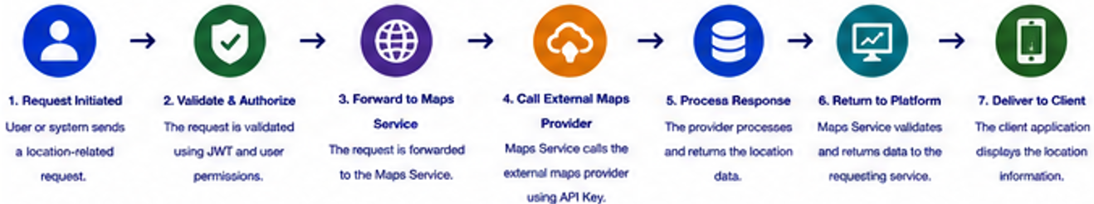
- The client application displays branch locations, navigation directions, travel distances, or suggestions of addresses to the customer.
Figure 13 - Maps Service Workflow

Notification APIs

Notification APIs are the functional module that provides an automated notification process to KriGo system customers, rental agencies, and platform administrators. It helps to send automated notifications to customers and other parties through multiple channels of communication, such as email, SMS, push notification, and in-app notification. In general, this module helps to make the communication processes automated, improves engagement and operational efficiency, and facilitates the distribution of important events.

The Notification APIs are constructed according to the RESTful architecture and interact with the external notification providers via standard protocols. Requests and responses are transmitted as JSON via HTTPS. Thus, the communication between the KriGo platform and third-party messaging services is safe and reliable. The integration layer provides abstraction from the implementation specifics of the notification providers, which allows extending and replacing the notification providers independently from the core business services of the platform.

Authorization via JSON Web Tokens (JWT) is required for all notification operations when they are performed by the authenticated services or users of the KriGo platform. The external communications with email and SMS providers are done through HTTPS and are protected using Transport Layer Security (TLS). The authentication with providers is done via the API keys or OAuth credentials depending on the notification provider used. The asynchronous message processing and delivery tracking are provided to increase scalability and guarantee delivery of the notification.

The Notification Service works together with the Authentication Service, Reservation Service, Payment Service, Customer Service, Agency Management Service, and Administration Service. Notifications are automatically sent for the important system events such as account creation, email verification, password reset, reservation confirmation, payment, booking cancellation, disputes, and administrative announcements. The delivery status and the notifications history are stored for monitoring purposes.

Notification API Endpoints
Table 18 - Notification API Endpoints
Endpoint | Method | Description | Auth
/api/v1/integrations/notifications/send | POST | Send a notification using the appropriate communication channel | Yes
/api/v1/integrations/notifications/email | POST | Send an email notification | Yes
/api/v1/integrations/notifications/sms | POST | Send an SMS notification | Yes
/api/v1/integrations/notifications/push | POST | Send a push notification | Yes
/api/v1/integrations/notifications/history | GET | Retrieve notification history | Yes
/api/v1/integrations/notifications/{notificationId} | GET | Retrieve notification details | Yes
/api/v1/integrations/notifications/status/{notificationId} | GET | Retrieve notification delivery status | Yes
/api/v1/integrations/notifications/webhook | POST | Receive delivery status callbacks from notification providers | No (Verified by Digital Signature)

API Design Considerations
The Notification APIs have been created following the following guidelines:
  - RESTful API design: The notification services are made available through the standardized REST endpoints that use JSON format.
  - JWT authentication: Authentication to protected endpoints is provided via JWT tokens.
  - Encrypted communications: All communications are encrypted using HTTPS and TLS.
  - Provider authentication: Third-party messaging providers are authenticated via API keys and OAuth.
  - Multichannel notifications: The notifications can be sent via email, SMS, push notifications, and in-app messaging.
  - Asynchronous notifications: Notifications are processed asynchronously to improve the system performance.
  - Notification status monitoring: The notification statuses are tracked via provider callbacks and delivery reports.
  - Dynamic message templates: Dynamic templates are used for message creation.
  - Delivery retries: The failed delivery attempts are automatically retried based on configured policies.
  - Notification auditing: The notifications are logged to be able to track requests and delivery events.

Notification Workflow
The process of notifications consists of the following steps:
  - An event on the platform, such as confirmation of booking or the transaction being completed, starts the notification process.
  - The notifying service checks the notification parameters and sends it to the Notification Service.
  - The Notification Service selects the required channel of communication and the corresponding template for the message.
  - The notification is sent to the external provider of messages in a secured manner.
  - The provider processes the request and sends back the result in the form of delivery or acknowledgment callback.
  - The status of the notification and its delivery details are updated by the Notification Service.
  - The client or administrator can view the history and status of delivery of notifications.

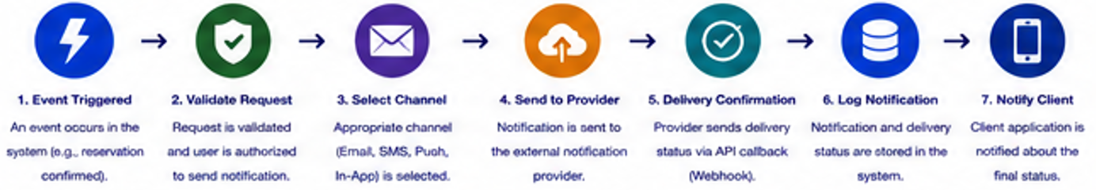
This approach allows ensuring secure, efficient, and tracked message delivery.
Figure 14 - Notification Workflow

API Security Specification

